Spiral 1 Completion Report
Role: Integration & Test Lead (Member 4)
Project: UML-Based Generic CRUD Application Generator

1. Objective of Spiral 1
The objective of Spiral 1 was to validate the feasibility of extracting structural information from UML Class Diagrams exported as XMI files. The focus was limited to:
- Extraction of class names
- Extraction of attributes
- Extraction of attribute data types
- Validation of model integrity
No SQL or code generation was included in this spiral.

2. Scope of Integration Work
As Integration Lead, the responsibilities included:
- Defining the internal JSON structure for the parsed UML model
- Integrating the parser module and validation module
- Designing the CLI interface
- Testing the system with multiple input models
- Verifying deterministic behavior

3. Internal Data Representation Design
A standardized internal structure was defined to ensure consistency across future spirals.
Example structure:
{
"classes": [
{
"name": "Student",
"attributes": [
{"name": "studentId", "type": "Integer"},
{"name": "name", "type": "String"}
]
}
]
}
Design Principles:
- Minimal and deterministic
- Independent of XMI structure
- Suitable for schema and code generation in later spirals

4. Module Integration
The following modules were integrated:
- XMI Parser Module
  - Extracts raw class and attribute data
- Validation Module
  - Detects duplicate class names
  - Detects duplicate attributes
  - Detects malformed XMI
- CLI Interface
Command format:
- python generate.py <input_file.xmi>
System Flow:
XMI File → Parser → Validation → JSON Output

5. Testing Strategy
The system was tested using four UML models:
- Single class model
- Two classes with attributes
- Model with inheritance
- Model with associations (structure extraction only)
Test Scenarios:
- Valid XMI input
- Corrupted XML file
- Duplicate class names
- Empty model
All validation errors produced clear and descriptive error messages.

6. Results
- Successful extraction of class and attribute information from all valid test models
- Correct rejection of invalid models
- Deterministic output verified (same input produces identical JSON structure)
- CLI interface functioning as expected
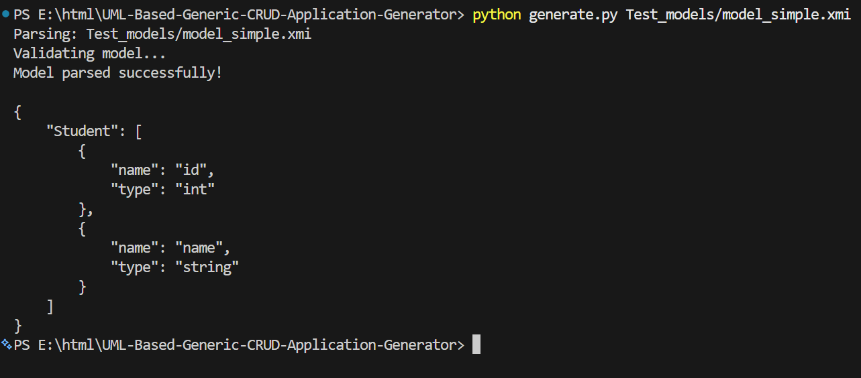
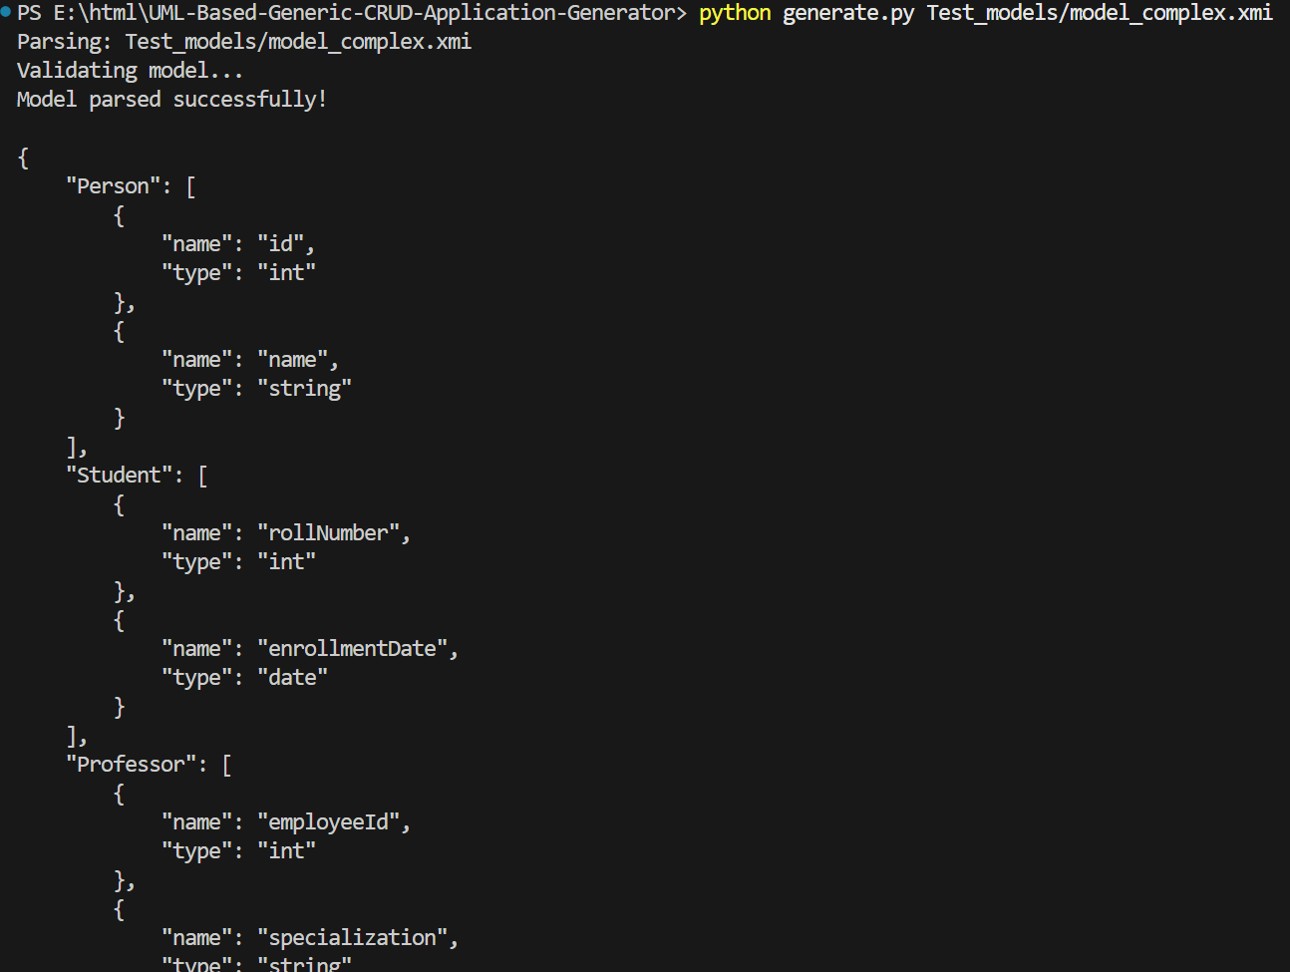
Spiral 1 objectives were achieved successfully.

7. Identified Risks for Next Spiral
- Type mapping may require normalization (case sensitivity handling)
- Association handling requires careful foreign key placement
- Large models may affect performance
These risks will be addressed in Spiral 2 and Spiral 3.

8. Conclusion
Spiral 1 established a stable foundation for the project by validating the feasibility of UML structure extraction. The internal model representation is consistent and ready for schema generation in the next iteration.
The system is now prepared for Spiral 2 implementation.

